Spearman rank correlation: NZDUSD and EURGBP
Method 02 / daily log returns / Alpari D1 full available history

Study setup
Logical pair: NZDUSD , EURGBP
Broker symbols: NZDUSD_i , EURGBP_i
Snapshot: 2026-11-03_majors_alpari_D1
Timeframe: D1
Matched return window: 1999-01-06 to 2026-11-02 (UTC bar dates)
Matched return count n: 7183
Dropped unfinished last bar dated 2026-11-03 UTC after a tick-volume check against the prior complete day.
Complete matched rows (CSV): NZDUSD-EURGBP_Spearman_D1.csv
Complete matched rows (HTML table): NZDUSD-EURGBP_Spearman_D1_data.html

Method carried forward
Spearman rho is Pearson correlation on the ranks of matched daily log returns of close, ln(close_t / close_t-1), in the broker quote direction. Ties use average ranks. Quotes are not inverted. rho is symmetric under swap of the two symbols. rho = 0 means no consistent rank-order link in this sample; it does not mean no link of any kind. The score is not a cause, not a lead, and not a trading signal. Daily rows are not independent draws, so the two-sided p-value and approximate Fisher interval are reported and treated as secondary to rho. Same-sample Pearson r is shown only as a side check; a large rho minus r gap can flag outliers or a non-straight link.

Results
Spearman rho: 0.055201
Two-sided p-value: 2.85211e-06
Approximate 95% Fisher interval: [0.032116, 0.078228]
Same-sample Pearson r: 0.037186
rho minus r: 0.018015

Conclusion
Over 7183 matched daily log-return rows for NZDUSD and EURGBP (broker quote directions unchanged), Spearman rho is 0.0552 (positive, weak rank-order association in this sample). Approximate 95% Fisher interval: [0.0321, 0.0782]. Same-sample Pearson r is 0.0372 (rho minus r = 0.0180). Two-sided p under the usual independent-ranks model is 2.852e-06; that model does not match linked daily FX returns, so treat p as secondary. This does not establish cause, lead-lag, or a lasting trading rule.

Charts
Daily closes

Daily log returns
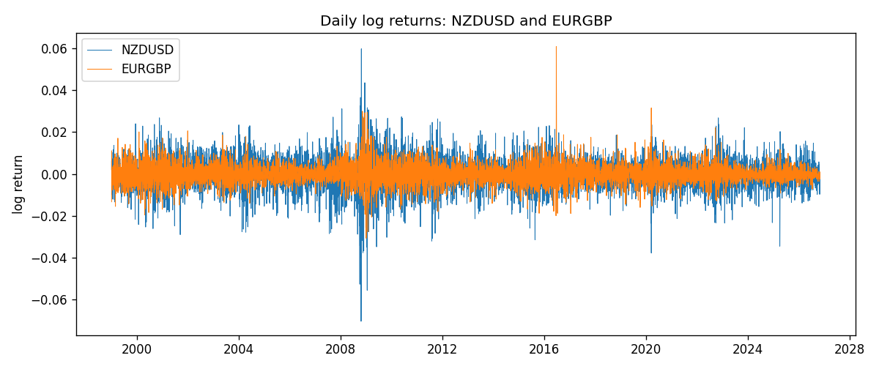
Log-return scatter
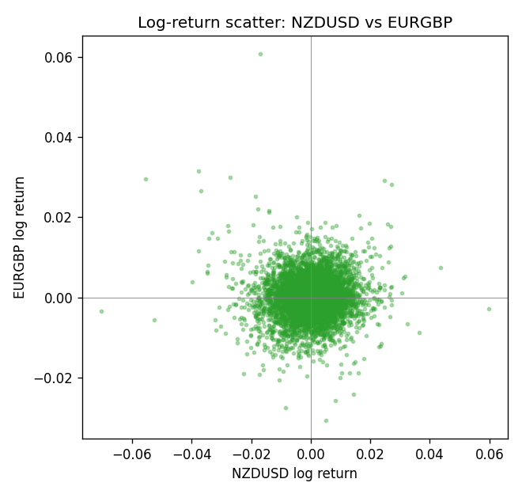
Rank-rank scatter
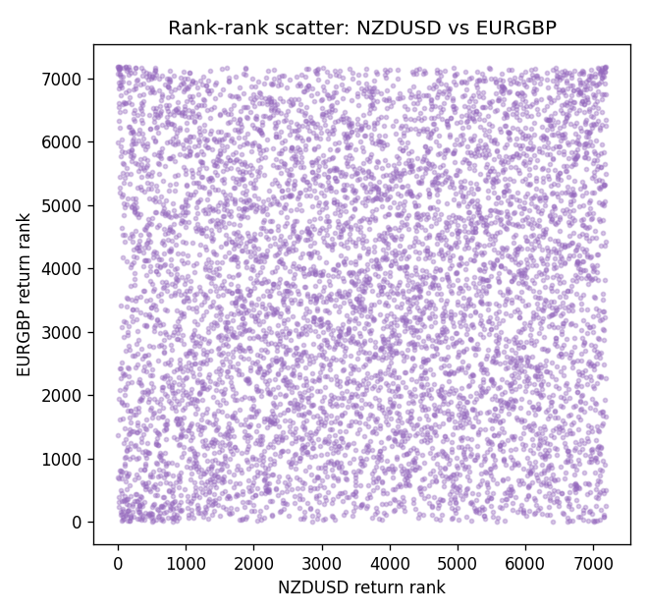

Data report
Every matched row that entered Spearman rho is stored in the sibling CSV named NZDUSD-EURGBP_Spearman_D1.csv. That file is the complete data archive for redrawing charts. Embedding all rows as a Word table is impractical at this length; the Word file holds the column list, column summaries, and the first and last 15 matched rows.
Columns: time, NZDUSD_open, EURGBP_open, NZDUSD_high, EURGBP_high, NZDUSD_low, EURGBP_low, NZDUSD_close, EURGBP_close, NZDUSD_tick_volume, EURGBP_tick_volume, NZDUSD_spread, EURGBP_spread, NZDUSD_real_volume, EURGBP_real_volume, NZDUSD_log_return, EURGBP_log_return
Column summaries (matched calculation rows)
column | count | mean | std | min | 25% | 50% | 75% | max
NZDUSD_open | 7183 | 0.65646991 | 0.10818219 | 0.3913 | 0.591455 | 0.6684 | 0.72495 | 0.88218
EURGBP_open | 7183 | 0.78694248 | 0.0966971 | 0.5734 | 0.68755 | 0.83389 | 0.86522 | 0.9769
NZDUSD_high | 7183 | 0.66038812 | 0.10867344 | 0.3961 | 0.5949 | 0.67204 | 0.729365 | 0.88421
EURGBP_high | 7183 | 0.7900202 | 0.09707133 | 0.5789 | 0.6896 | 0.8369 | 0.8681 | 0.9799
NZDUSD_low | 7183 | 0.65278196 | 0.10777661 | 0.3897 | 0.58816 | 0.6642 | 0.720985 | 0.87988
EURGBP_low | 7183 | 0.78424251 | 0.0965143 | 0.5682 | 0.6855 | 0.83166 | 0.86287 | 0.9661
NZDUSD_close | 7183 | 0.65654354 | 0.10817679 | 0.3907 | 0.59181 | 0.6685 | 0.72502 | 0.8822
EURGBP_close | 7183 | 0.78698724 | 0.09669475 | 0.5735 | 0.68775 | 0.83395 | 0.86536 | 0.977
NZDUSD_tick_volume | 7183 | 68736.568 | 123152.54 | 16 | 5594.5 | 33901 | 58513.5 | 1127682
EURGBP_tick_volume | 7183 | 87133.158 | 145499.84 | 154 | 6553 | 44358 | 81413 | 1424684
NZDUSD_spread | 7183 | 30.260755 | 25.633067 | 0 | 9 | 17 | 40 | 80
EURGBP_spread | 7183 | 21.328832 | 19.122264 | 0 | 4 | 13 | 40 | 50
NZDUSD_real_volume | 7183 | 1.6708354e+10 | 8.49951e+10 | 0 | 0 | 0 | 0 | 2.705649e+12
EURGBP_real_volume | 7183 | 2.7872287e+10 | 1.3521454e+11 | 0 | 0 | 0 | 0 | 3.5726265e+12
NZDUSD_log_return | 7183 | 1.073e-05 | 0.0076464 | -0.07027433 | -0.00425909 | 0.00022967 | 0.00458236 | 0.05966839
EURGBP_log_return | 7183 | 2.33e-05 | 0.00487088 | -0.03067367 | -0.00262163 | -9.879e-05 | 0.002558 | 0.06075387
First 15 matched rows (selected columns)
time | NZDUSD_close | EURGBP_close | NZDUSD_log_return | EURGBP_log_return | NZDUSD_tick_volume | EURGBP_tick_volume
1999-01-06 | 0.5383 | 0.7019 | 0.0020455609 | -0.013303338 | 823 | 2635
1999-01-07 | 0.5417 | 0.7097 | 0.0062963171 | 0.011051402 | 878 | 2464
1999-01-08 | 0.5414 | 0.7062 | -0.00055396548 | -0.004943862 | 668 | 3132
1999-01-11 | 0.547 | 0.7053 | 0.010290425 | -0.0012752393 | 681 | 2418
1999-01-12 | 0.5441 | 0.7077 | -0.0053157489 | 0.0033970309 | 793 | 2670
1999-01-13 | 0.5387 | 0.708 | -0.0099742238 | 0.00042381861 | 1050 | 2612
1999-01-14 | 0.5386 | 0.7066 | -0.00018564931 | -0.0019793588 | 1137 | 2560
1999-01-15 | 0.5382 | 0.7012 | -0.00074294208 | -0.0076715819 | 1124 | 3031
1999-01-18 | 0.5372 | 0.7017 | -0.0018597736 | 0.00071280921 | 1022 | 2461
1999-01-19 | 0.5382 | 0.7007 | 0.0018597736 | -0.0014261269 | 1389 | 2606
1999-01-20 | 0.5404 | 0.7021 | 0.0040793678 | 0.0019960086 | 1678 | 2341
1999-01-21 | 0.5426 | 0.7016 | 0.0040627941 | -0.00071240297 | 1599 | 2450
1999-01-22 | 0.5361 | 0.7004 | -0.012051689 | -0.0017118406 | 1328 | 2600
1999-01-25 | 0.5342 | 0.6966 | -0.0035504102 | -0.0054402425 | 1035 | 2304
1999-01-26 | 0.5381 | 0.6962 | 0.0072741158 | -0.00057438255 | 1399 | 3025
Last 15 matched rows (selected columns)
time | NZDUSD_close | EURGBP_close | NZDUSD_log_return | EURGBP_log_return | NZDUSD_tick_volume | EURGBP_tick_volume
2026-10-13 | 0.56127 | 0.84458 | 0.0047326165 | 0.00020130374 | 27958 | 30915
2026-10-14 | 0.55918 | 0.84553 | -0.0037306483 | 0.0011241873 | 37319 | 39105
2026-10-15 | 0.56185 | 0.84479 | 0.0047634855 | -0.00087557391 | 43714 | 45290
2026-10-16 | 0.56509 | 0.84307 | 0.0057501001 | -0.0020380844 | 35806 | 39309
2026-10-19 | 0.56616 | 0.84259 | 0.0018917133 | -0.00056950988 | 32069 | 38133
2026-10-20 | 0.56827 | 0.83957 | 0.0037199341 | -0.0035906254 | 34470 | 42542
2026-10-21 | 0.57003 | 0.83839 | 0.0030923331 | -0.00140647 | 30020 | 35843
2026-10-22 | 0.56815 | 0.83682 | -0.0033035227 | -0.0018743924 | 39159 | 44479
2026-10-23 | 0.56991 | 0.83751 | 0.0030929853 | 0.00082421033 | 33693 | 37399
2026-10-26 | 0.56826 | 0.83762 | -0.0028993932 | 0.00013133309 | 30716 | 38735
2026-10-27 | 0.56811 | 0.83595 | -0.00026399852 | -0.0019957343 | 32660 | 36303
2026-10-28 | 0.56261 | 0.83651 | -0.0097283914 | 0.00066967224 | 42740 | 36532
2026-10-29 | 0.56296 | 0.83553 | 0.00062190714 | -0.0011722209 | 40247 | 49261
2026-10-30 | 0.56307 | 0.83351 | 0.00019537668 | -0.0024205543 | 39305 | 44060
2026-11-02 | 0.56161 | 0.83426 | -0.0025962955 | 0.00089940465 | 35347 | 43437

